Qwiklabs Assessment: Fixing Errors in Python Scripts

**Introduction**

You're an IT professional who's in charge of the deployment and maintenance of software in your company's fleet. A piece of software that's deployed on all machines in your fleet is throwing an error on a number of these machines. You haven't written the software and don't have access to the source code. You'll need to examine the environment where the software is running in and try to work out what's going on.

**What you'll do**

* Understand the error messages
* Track down the root cause and work to fix it
* Understand what to do when you can't modify the program that's throwing errors

**You'll have 90 minutes to complete this lab.**

linux-instance external IP address



content\_copy

username



content\_copy

[file\_download](https://googlecoursera.qwiklabs.com/lab_instances/download_pem/15727903" \t "_blank)

[Download PEM](https://googlecoursera.qwiklabs.com/lab_instances/download_pem/15727903" \t "_blank)

[file\_download](https://googlecoursera.qwiklabs.com/lab_instances/download_ppk/15727903" \t "_blank)

[Download PPK](https://googlecoursera.qwiklabs.com/lab_instances/download_ppk/15727903" \t "_blank)

# **Fix errors with a crashing script**

## Introduction

You're an IT professional who's in charge of the deployment and maintenance of software in your company's fleet. A piece of software that's deployed on all machines in your fleet is throwing an error on a number of these machines. You haven't written the software and don't have access to the source code. You'll need to examine the environment where the software is running in and try to work out what's going on.

#### **What you'll do**

* Understand the error messages
* Track down the root cause and work to fix it
* Understand what to do when you can't modify the program that's throwing errors

You'll have 90 minutes to complete this lab.

### **Start the lab**

You'll need to start the lab before you can access the materials in the virtual machine OS. To do this, click the green “Start Lab” button at the top of the screen.

**Note:** For this lab you are going to access the **Linux VM** through your **local SSH Client**, and not use the **Google Console** (**Open GCP Console** button is not available for this lab).

Start Lab

After you click the “Start Lab” button, you will see all the SSH connection details on the left-hand side of your screen. You should have a screen that looks like this:

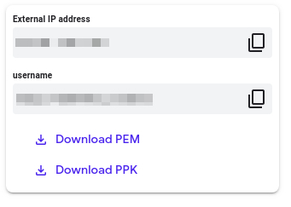

## Accessing the virtual machine

Please find one of the three relevant options below based on your device's operating system.

**Note:** Working with Qwiklabs may be similar to the work you'd perform as an **IT Support Specialist**; you'll be interfacing with a cutting-edge technology that requires multiple steps to access, and perhaps healthy doses of patience and persistence(!). You'll also be using **SSH** to enter the labs -- a critical skill in IT Support that you’ll be able to practice through the labs.

### **Option 1: Windows Users: Connecting to your VM**

In this section, you will use the PuTTY Secure Shell (SSH) client and your VM’s External IP address to connect.

**Download your PPK key file**

You can download the VM’s private key file in the PuTTY-compatible **PPK** format from the Qwiklabs Start Lab page. Click on **Download PPK**.



**Connect to your VM using SSH and PuTTY**

1. You can download Putty from [here](https://the.earth.li/~sgtatham/putty/latest/w64/putty.exe)
2. In the **Host Name (or IP address)** box, enter username@external\_ip\_address.

**Note:** Replace **username** and **external\_ip\_address** with values provided in the lab.



1. In the **Category** list, expand **SSH**.
2. Click **Auth** (don’t expand it).
3. In the **Private key file for authentication** box, browse to the PPK file that you downloaded and double-click it.
4. Click on the **Open** button.

**Note:** PPK file is to be imported into PuTTY tool using the Browse option available in it. It should not be opened directly but only to be used in PuTTY.



1. Click **Yes** when prompted to allow a first connection to this remote SSH server. Because you are using a key pair for authentication, you will not be prompted for a password.

**Common issues**

If PuTTY fails to connect to your Linux VM, verify that:

* You entered **<username>**@**<external ip address>** in PuTTY.
* You downloaded the fresh new PPK file for this lab from Qwiklabs.
* You are using the downloaded PPK file in PuTTY.

### **Option 2: OSX and Linux users: Connecting to your VM via SSH**

**Download your VM’s private key file.**

You can download the private key file in PEM format from the Qwiklabs Start Lab page. Click on **Download PEM**.

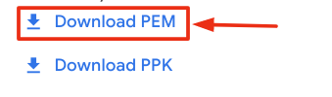

**Connect to the VM using the local Terminal application**

A **terminal** is a program which provides a **text-based interface for typing commands**. Here you will use your terminal as an SSH client to connect with lab provided Linux VM.

1. Open the Terminal application.
   * To open the terminal in Linux use the shortcut key **Ctrl+Alt+t**.
   * To open terminal in **Mac** (OSX) enter **cmd + space** and search for **terminal**.
2. Enter the following commands.

**Note:** Substitute the **path/filename for the PEM** file you downloaded, **username** and **External IP Address**.

You will most likely find the PEM file in **Downloads**. If you have not changed the download settings of your system, then the path of the PEM key will be **~/Downloads/qwikLABS-XXXXX.pem**

chmod 600 ~/Downloads/qwikLABS-XXXXX.pem

ssh -i ~/Downloads/qwikLABS-XXXXX.pem username@External Ip Address

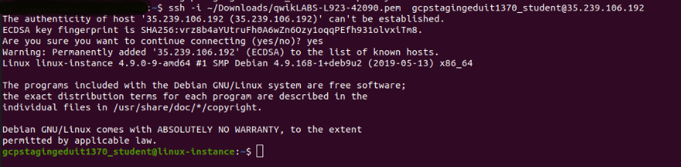

### **Option 3: Chrome OS users: Connecting to your VM via SSH**

**Note:** Make sure you are not in **Incognito/Private mode** while launching the application.

**Download your VM’s private key file.**

You can download the private key file in PEM format from the Qwiklabs Start Lab page. Click on **Download PEM**.



**Connect to your VM**

1. Add Secure Shell from [here](https://chrome.google.com/webstore/detail/secure-shell-app/pnhechapfaindjhompbnflcldabbghjo) to your Chrome browser.
2. Open the Secure Shell app and click on **[New Connection]**.

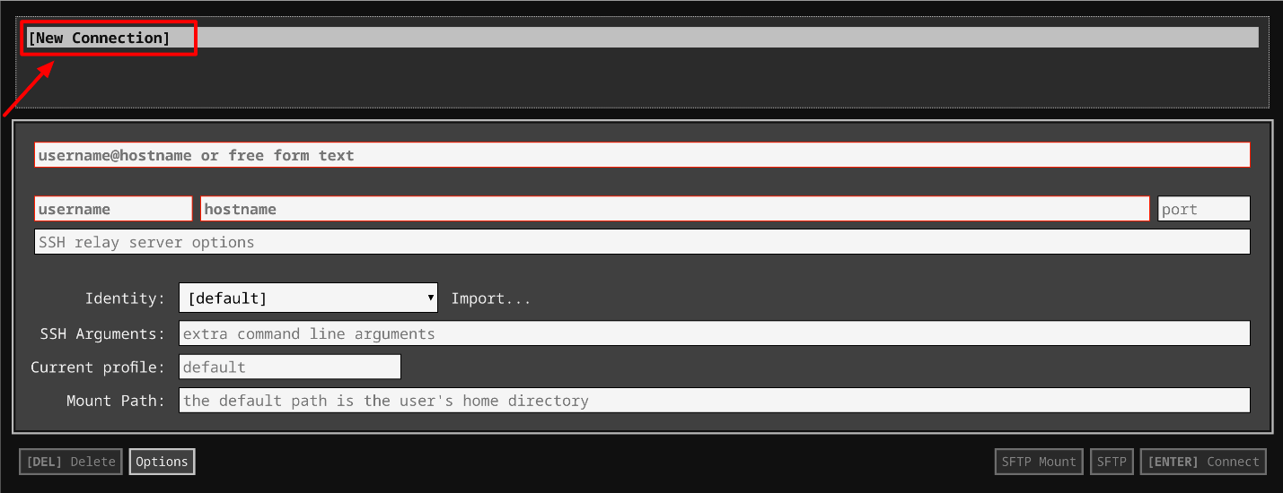

1. In the **username** section, enter the username given in the Connection Details Panel of the lab. And for the **hostname** section, enter the external IP of your VM instance that is mentioned in the Connection Details Panel of the lab.

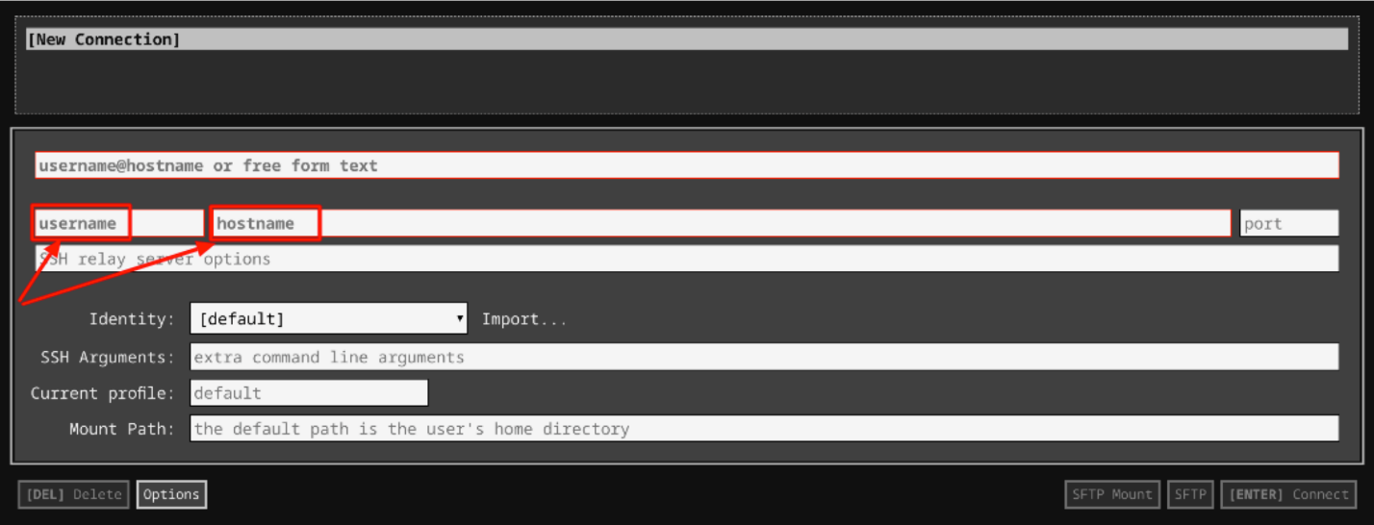

1. In the **Identity** section, import the downloaded PEM key by clicking on the **Import…** button beside the field. Choose your PEM key and click on the **OPEN** button.

**Note:** If the key is still not available after importing it, refresh the application, and select it from the **Identity** drop-down menu.

1. Once your key is uploaded, click on the **[ENTER] Connect** button below.

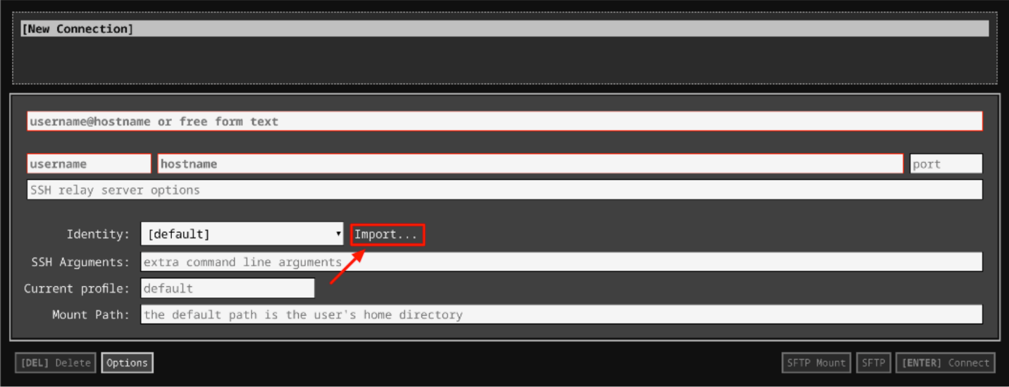

1. For any prompts, type **yes** to continue.
2. You have now successfully connected to your Linux VM.

You're now ready to continue with the lab!

## ImportError

Since you haven't written the software and don't have access to the source code, you'll need to examine the environment where the software is running and try to work out what's going on. There's a python script named infrastructure in /usr/bin directory that reads data from a CSV file and prints them to the terminal in a nicely formatted manner. Let's run this script and see whether it generates any errors.

Now change the directory to root, and run the script.

cd /

python3 /usr/bin/infrastructure

Output:

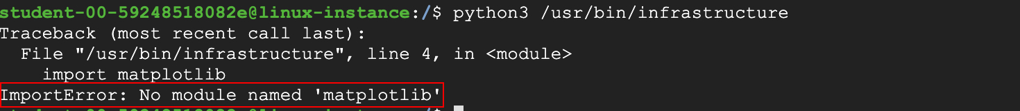

The script crashed, displaying an ImportError. This error is raised when an import statement has trouble importing a specific module. You could also see the module that the import statement hasn't found (i.e. matplotlib). We'll need to import this module before we continue to run the script again.

### **Fix:**

In order to fix this error, you first need to install **pip3** which is a Python package installer. This downloads and configures new python modules with single-line commands.

sudo apt install python3-pip

Now, install the matplotlib python library using pip3:

pip3 install matplotlib

Matplotlib is a plotting library for the Python programming language and its numerical mathematics extension **NumPy**(installed upon installing matplotlib). It provides an object-oriented API for embedding plots into applications using general-purpose GUI toolkits. Even simpler, it's a visualization library in Python for 2D plots of arrays.

Click Check my progress to verify the objective.

Download 'matplotlib' module

Check my progress

## NoFileError

After installing the necessary modules, run the script again.

python3 /usr/bin/infrastructure

Output:



This time it returns a NoFileError with a message that it could not find data.csv file in the working directory. Try debugging this issue.

### **Fix:**

Let's navigate to the working directory and see if the data.csv file exists.

cd ~

ls

Output:



As you can see, the file data has the extension .bak. As we mentioned earlier, the script infrastructure works on CSV files. Interpret the error message, which also says that it didn't find a data.csv file. We've now found the root cause of the issue. Let's move forward by renaming the file data.bak to data.csv.

mv data.bak data.csv

Click Check my progress to verify the objective.

Rename data.csv file

Check my progress

Now, navigate back to the root directory and run the script again.

cd /

python3 /usr/bin/infrastructure

Output:



This now gives a MissingColumnError. It says that it couldn't find a column named "company" within the data.csv file.

## MissingColumnError

Let's check the data.csv file for the missing column name.

cat ~/data.csv

Output:

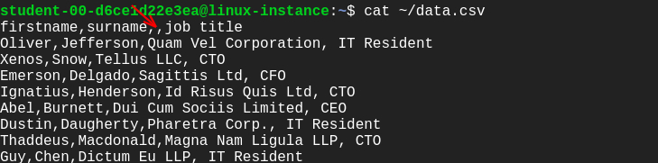

So, the column name is actually missing. Let's add the column name and run the script again.

Grant the permissions to the data.csv file.

sudo chmod 777 ~/data.csv

Open data.csv file using nano editor.

nano ~/data.csv

Add the missing column name and save the file by clicking Ctrl-o, followed by Enter key and Ctrl-x.

Now, run the script again:

python3 /usr/bin/infrastructure

Output:



This time you fixed all the errors!

Click Check my progress to verify the objective.

Add column in data.csv

Check my progress

## Congratulations!

Congrats! You've correctly understood the error messages and fixed them by tracking down the root cause. This will help you as an IT professional who's in charge of the deployment and maintenance of software in your company's fleet.

## End your lab